**ESTIMATION OF BUSINESS EXPENSESS**

**PROJECT REPORT**

* **INTRODUCTION:**

Business expenses refer to the costs incurred by a company or organization in the process of conducting its operations, with the aim of generating revenue and achieving its business objectives. These expenses are an essential component of any business's financial management and play a crucial role in determining the company's profitability, tax liability, and overall financial health.

Business expenses can encompass a wide range of categories, including:

* **Operational Expenses:** These are the day-to-day costs required to keep a business running, such as rent, utilities, office supplies, and employee salaries.
* **Cost of Goods Sold (COGS):** These expenses relate to the production or procurement of goods or services that a business sells. For example, for a retail store, this would include the cost of purchasing inventory.
* **Marketing and Advertising:** Expenses associated with promoting and advertising the business to attract customers, such as advertising campaigns, social media marketing, and promotional materials.
* **Travel and Entertainment:** Costs related to business travel, client meetings, and entertainment for clients or business partners.
* **Depreciation:** The allocation of the cost of assets over their useful life to reflect wear and tear, typically used for tangible assets like machinery or vehicles.
* **Interest and Financing Costs:** Interest payments on loans or credit lines and any other financing expenses.
* Overview:

A comprehensive overview of business expenses is crucial for effective financial management and decision-making. Business expenses can be categorized into various types, each of which plays a different role in a company's financial health. Here's a more detailed breakdown:

1. **Operating Expenses:** These are ongoing, day-to-day costs associated with running the business. Common operating expenses include rent or lease payments for office space, utilities (electricity, water, etc.), salaries and wages for employees, office supplies, insurance premiums, and maintenance costs.
2. **Cost of Goods Sold (COGS):** For businesses that sell products, COGS represents the direct costs associated with producing or procuring the goods that are sold. This includes expenses like raw materials, labor, and manufacturing costs. For service-based businesses, COGS may include labor and materials required to deliver the service.
3. **Marketing and Advertising Expenses:** These include costs related to promoting the business, such as advertising campaigns, online marketing, print materials, social media advertising, and expenses associated with trade shows or events.
4. **Travel and Entertainment:** Expenses incurred for business-related travel, client meetings, or entertaining clients. This can include airfare, accommodations, meals, and entertainment costs.
5. **Depreciation:** Depreciation is a non-cash expense that represents the allocation of the cost of long-term assets over their useful life. It's used for assets like buildings, vehicles, and machinery.

PURPOSE:

The purpose of business expenses is multifaceted and essential to the financial management and operation of a company. Business expenses serve several key purposes, including:

1. **Cost Tracking:** Business expenses help companies track the costs associated with their operations. This allows for an accurate assessment of the resources required to run the business, which is crucial for budgeting and financial planning.
2. **Profit Determination:** By subtracting total expenses from revenue, businesses can determine their profitability. The difference between revenue and expenses is known as net income. Profitability is a key indicator of a company's financial health.
3. **Taxation:** Accurate tracking and documentation of business expenses are critical for tax purposes. Many expenses can be tax-deductible, which reduces a company's taxable income and, consequently, its tax liability. Properly managing expenses can result in significant tax savings.
4. **Budgeting and Financial Planning:** Business expenses are essential for creating budgets and financial forecasts. Understanding and managing expenses helps companies set financial goals and allocate resources efficiently.
5. **Understanding Industry Evolution:** To gain insight into the changing landscape of the transportation and technology industry and how Uber is positioning itself within this transformation.
6. **Problem Identification:** To identify and evaluate the key challenges and obstacles Uber faces in its expeditionary analysis, allowing for a comprehensive understanding of the project's complexities.
7. **Solutions Assessment:** To assess the strategies and solutions Uber employs to address these challenges, providing valuable insights for businesses and stakeholders in the autonomous vehicle sector.
8. **Safety and Regulatory Considerations:** To explore the safety and regulatory aspects of autonomous vehicles, which are paramount for the success of Uber's project and the industry at large.
9. **Market and Public Perception:** To investigate the public's perception and acceptance of autonomous technology, which is essential for widespread adoption and success in the market.
10. **Economic Implications:** To analyze the economic impact of Uber's autonomous vehicle efforts, including cost management, revenue models, and financial sustainability.

* **PROBLEM DEFINITION & DESIGN THINKING:**

* EMPATHY MAP:

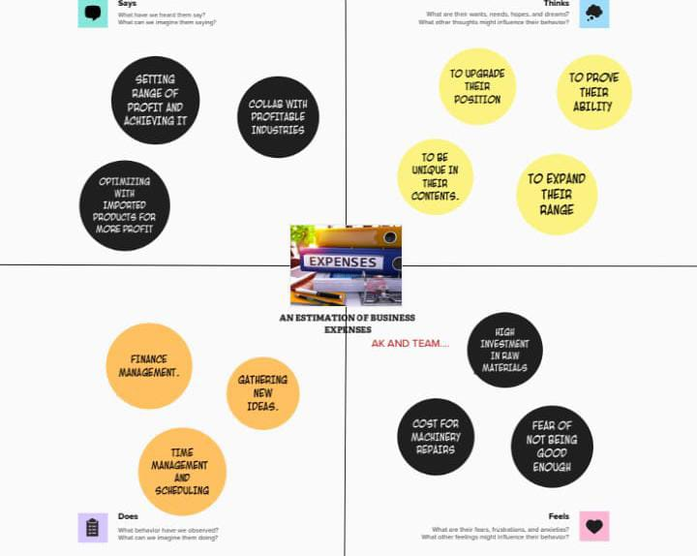

* BRAINSTORMING MAP:

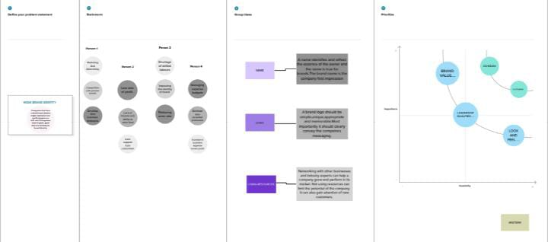

* **RESULT:**
* **Screen shots:**

**Dashboard 1**

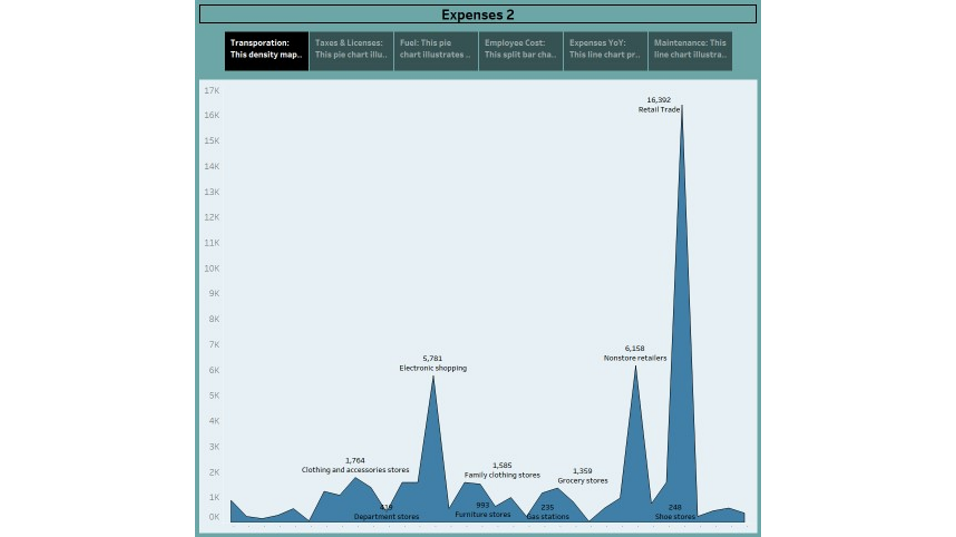

Dashboard 2

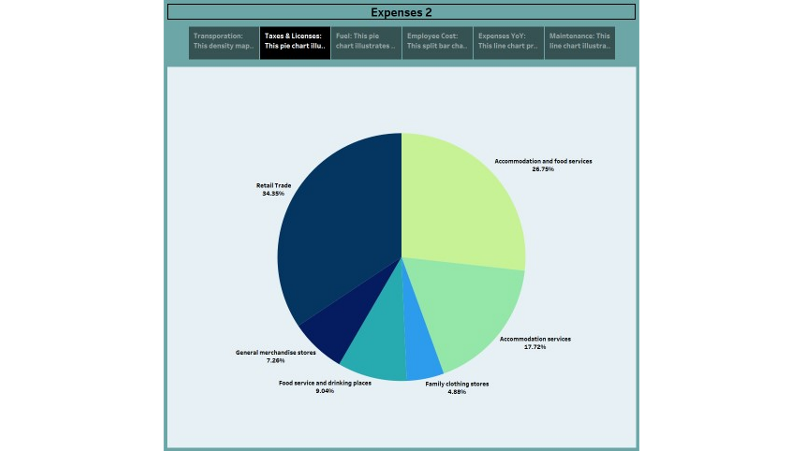

DASHBOARD 3 :

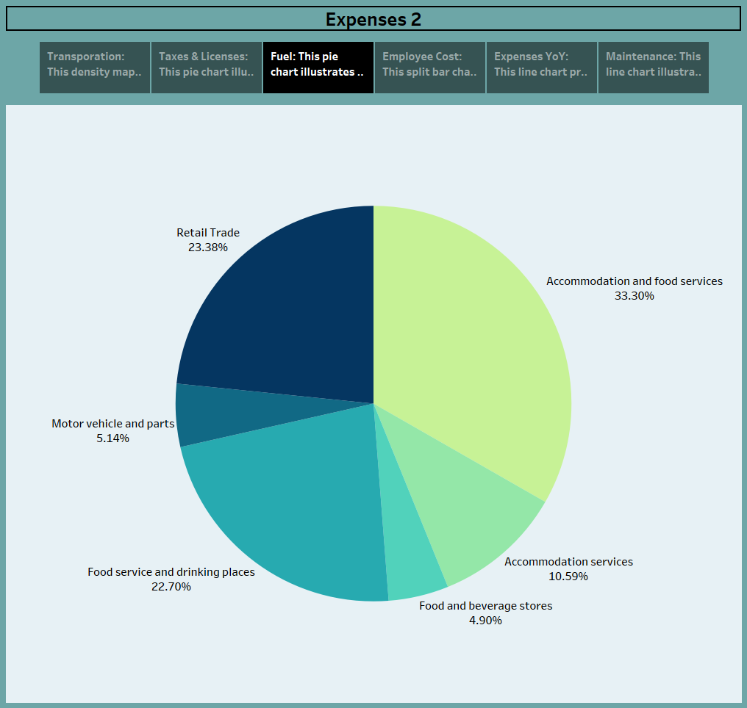

STORY :

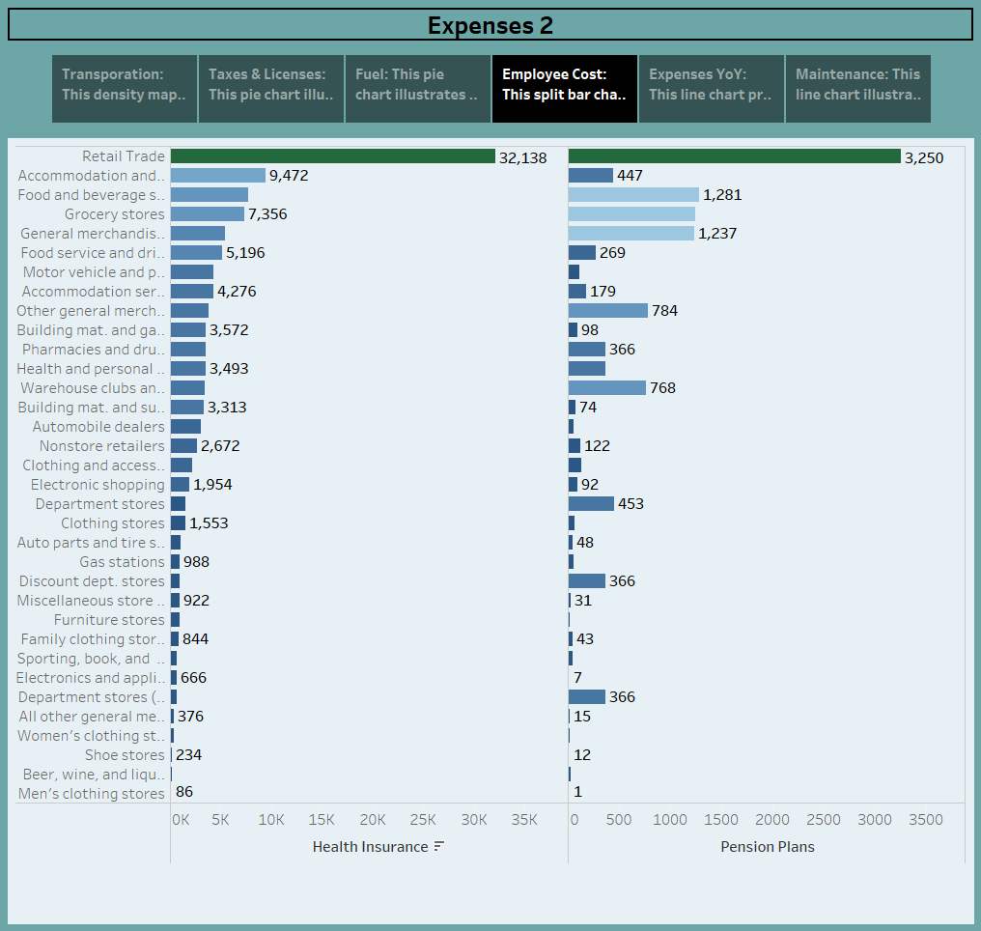

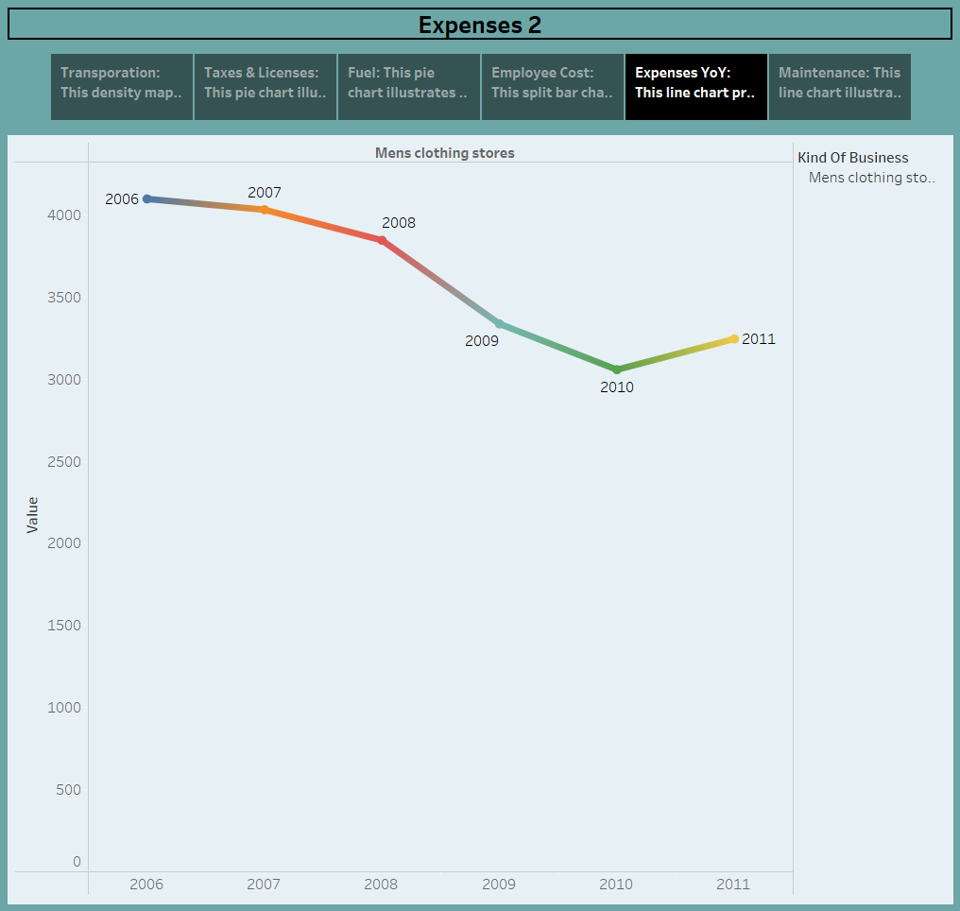

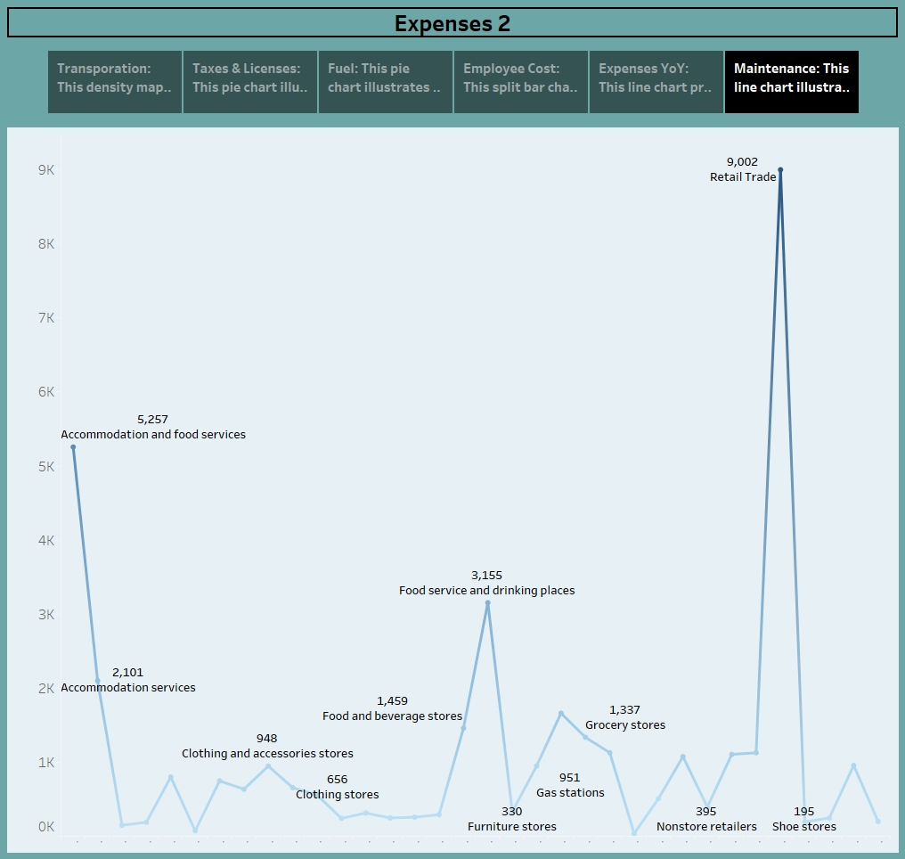

* **ADVANTAGES & DISADVANTAGES:**

Certainly! Here are some advantages and disadvantages of business expenses:

**Advantages:**

1. **Tax Benefits:** One of the significant advantages of business expenses is that many of them are tax-deductible. This can lead to lower taxable income, reducing the overall tax liability for the business.
2. **Financial Control:** Tracking expenses provides a clear view of how money is being spent within the company. This helps in identifying areas where cost-cutting is possible and optimizing resource allocation.
3. **Budgeting and Planning:** Expenses are a fundamental component of budgeting and financial planning. By analyzing past expenses, businesses can set realistic financial goals and allocate resources effectively.
4. **Profit Analysis:** Monitoring expenses allows companies to calculate their profitability accurately. This insight is crucial for assessing the financial health of the business and making informed decisions.
5. **Resource Management:** Understanding expenses helps in managing resources efficiently. Companies can make strategic decisions about where to invest or cut back, ensuring that money is used wisely.

**Disadvantages:**

1. **Financial Strain:** Excessive or unplanned expenses can strain a company's finances, leading to cash flow issues, debt accumulation, or even bankruptcy.
2. **Complexity:** Tracking and managing expenses can be complex, especially for larger businesses with numerous cost centers. It requires meticulous record-keeping and accounting expertise.
3. **Time-Consuming:** Expense management, including recording, categorizing, and analyzing expenses, can be time-consuming. This administrative burden can divert time and resources from other critical business activities.
4. **Overlooked Expenses:** In some cases, businesses may overlook certain expenses or fail to categorize them accurately, leading to incomplete financial records and inaccurate profitability assessments.
5. **Cost of Compliance:** Adhering to tax laws and regulations related to expenses can be costly. Businesses may need to hire tax professionals or invest in accounting software to ensure compliance.

**CONCLUSION:**

In conclusion, business expenses play a critical role in the financial management and overall success of a company. They serve multiple purposes, including tax benefits, financial control, budgeting, profit analysis, and resource management. By carefully tracking and managing expenses, businesses can optimize their financial performance and make informed decisions.

* **FUTURE SCOPE :**

The future scope of managing business expenses is promising and likely to evolve in several ways:\

1. **Technology Integration:** The integration of advanced technologies like artificial intelligence and machine learning will simplify and automate expense tracking and management. AI-driven expense management systems can provide real-time insights, identify cost-saving opportunities, and improve accuracy.
2. **Mobile Expense Management:** Mobile apps and cloud-based platforms for expense management will continue to gain popularity, allowing employees to submit expenses on the go and managers to approve them swiftly. This trend will contribute to efficiency and transparency.
3. **Sustainability Expenses:** With a growing focus on sustainability and environmental responsibility, businesses may need to track and manage expenses related to eco-friendly initiatives and green technologies.